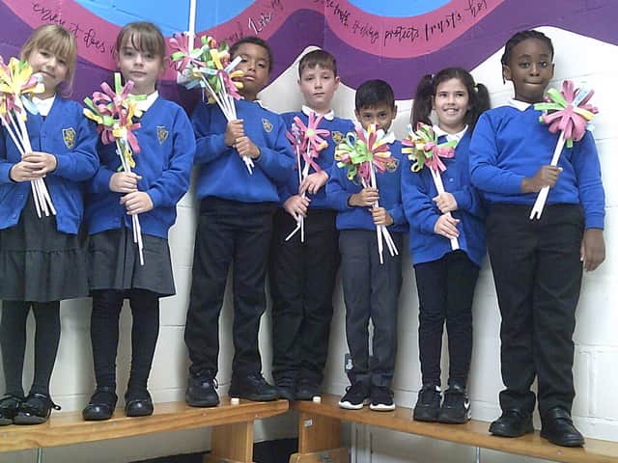
Kettering pupils dedicate artwork to their 'inspirational' Queen

The children at St Mary’s Primary School wanted to send messages of comfort, encouragement and hope to the Royal Family

Pupils at a Kettering school have used their artwork to pay tribute to Queen Elizabeth II.
Youngsters at St Mary’s Primary School in Fuller Street were greatly saddened by the death of the Queen last week.
She remains an inspiration to the school’s children, staff and families, and the children wanted to find ways to send messages of comfort, encouragement and hope to the Royal family.
A school spokesman said: “Through our collective worship and class learning, the children have been able to identify the devotion and dutiful service that the Queen offered to us all.
“Our key values, justice, friendship, forgiveness, aspiration and hope, were highlighted through acts of kindness and service demonstrated by the Queen during her 70-year reign.
“We listened to the speech made by Queen Elizabeth when she was just 21 and then reiterated over the years which made us think about our vision to care and love one another.
“It helped us to consider how we could serve others.
“The children were inspired to find ways to share the message of hope with others, they created a wreath of comfort and thanksgiving and a bouquet of flower messages.”
The school’s assistant headteacher, Sam Perry, visited Buckingham Palace to pay her respects on Saturday (September 10).
She said: “The scene was extremely moving as I laid the bouquet and wreath down; our school vision - do everything in love - is epitomised in the way Queen Elizabeth has served the nation.
"Her devotion to us has touched our lives and enabled us to inspire our children to act as courageous advocates for others.
"The crowds around Buckingham Palace cheered as King Charles III drove down the Mall and entered Buckingham Palace.
"I felt tremendously privileged to be there.
"A time for reflection, contemplation and thanks to the Queen who did so much for so many.”
Sam was interviewed by news reporters from around the world, highlighting the impact that this loss will have globally.
The children at St Mary’s continue to reflect on the dedication of the work of the Queen and have been considering ways that they might demonstrate love to others.


