 St Mary's CEVA Primary School



Addition

Skill | Year Group(s) | Representations and models
Add two 1-digit numbers  to 10 | 1 | Objects, Numicon, tens frames (within 10), part-whole model, number line (labelled).
Add 1 and 2-digit num- bers to 20 | 1/2 | Objects, Numicon, tens frames (within 20), part-whole model, number line (labelled), straws.
Add 3 1-digit numbers | 2 | Part-whole model, bar model, tens frames (within 20), jottings.
Add 1 and 2-digit num-  bers to 100. | 2/3 | Part-whole model, bar model, number lines (labelled), hundred square, Base 10, jottings, column addition
Add two 2-digit numbers to 100. | 2/3 | Part-whole model, bar model, number lines (labelled), hundred square, jottings, column addition.
Add numbers with up to | 3 | Part-whole model, bar model, Base 10, place value counters, column addition.
Add numbers with up to  4-digits | 4 | Part-whole model, bar model, Base 10, place value counters, column addition.
Add numbers with more than 4-digits. | 5/6 | Part-whole model, bar model, place value counters, column addition.
Add numbers with up to  3 decimal places. | 5/6 | Part-whole model, bar model, place value counters, column addition.

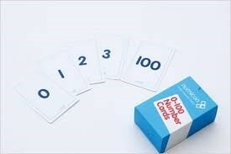
Skill: Adding 1-digit numbers to 10
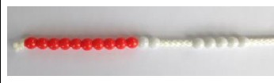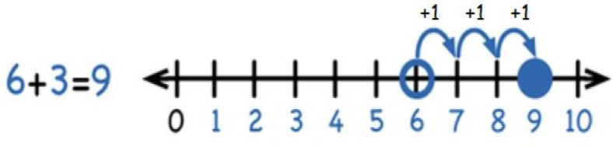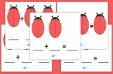
CONCRETE (objects)
AUGMENTATION STRUCTURE —counting
on and increasing
Start with the larger number on the bead string and then add on the smaller number 1 by 1 to find the total.
Count aloud.
PICTORIAL
AUGMENTATION STRUCTURE: - Counting on and increasing
This phase can be supported alongside the con- crete phase, using cubes or bead strings to show the connection to the number line.
The children have a starting point (which they do not need to count as with the aggregation struc- ture). They should now ‘count on’ along the num- ber line.
Children put the largest number into their heads and then count on from that point either by physi- cally moving themselves along a larger number line or by using their finger on a smaller one.
Focus more on the actions and language used to link the picture (number line) to their language of what is happening.
ABSTRACT a
Children should now use the concrete or pictorial phas- es to develop the link with making mathematical state- ments from what they are doing/seeing and what lan- guage they are using.

E.g. Six and three more equals nine.
6 + 3 = 9

Start by using numeral and symbol cards that can be manipulated into forming mathematical statements.
Then move on to children filling in writing frames by writing in the numerals and symbols into empty boxes.
Finally, children should be able to com-
pose mathematical statements of their own to demonstrate what has happened.
5 + 4 = 9
ABSTRACT b
Place the larger number in your head and count on the smaller number to find the total.

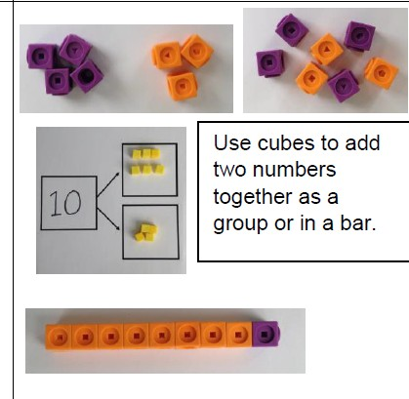
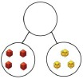
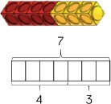
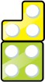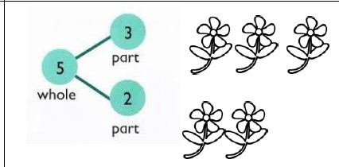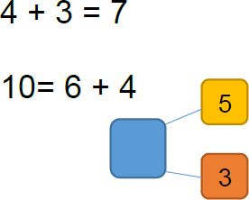
Skill: Adding 1-digit numbers to 10
CONCRETE (objects)
AGGREGATION STRUCTURE—the union of two sets
Use two sets of objects, join them altogether and count to find the total.
PART-WHOLE MODEL
Use a range of objects to model this and make it cross curricular where possible.
PICTORIAL
AGGREGATION STRUCTURE—the union
of two sets
Use pictures to add two numbers together as a group or in a bar.
PART-WHOLE MODEL
ABSTRACT
AGGREGATION STRUCTURE—the union of
two sets
Use part-whole models to move into abstract and to introduce missing number problems and use language to discuss mathematical state- ments and symbols.


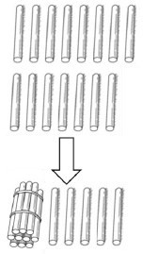
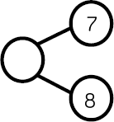
Skill: Add 1 and 2-digit numbers to 20
Year 1/2
When adding 1-digit numbers that cross 10, it is important to highlight the importance of ten ones equalling one ten. It is best to ensure this concept is fully understood in the concrete phase before moving into the pictorial or abstract phase.
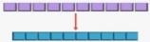
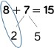
CONCRETE (objects)
Use two sets of objects, join them altogether and count to find the total—PART-WHOLE MODEL
Use a range of objects to model this and make it cross curricular where possible.

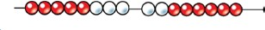

In Year 2, the focus will be on exchanging groups ten of ones for a ten ‘stick’ or ’bundle’.
ten ones

one group of 10
The children will also become familiar with using the physical Base 10 (tens ‘sticks’ and ones).
PICTORIAL
In Year 1, children use a number line or draw Numicon jottings to help them solve these calculations when using the pictorial ap- proach.

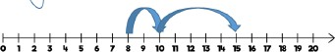

In Year 2, children will use Base 10 jottings to support them to solve the calculation.
For example, 8 + 7 =
ABSTRACT
Children will use part-whole models to move into abstract and to introduce missing num- ber problems and use language to discuss mathematical statements and symbols.

8 + 7=15

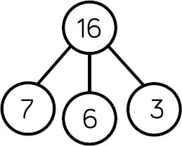
When adding three 1-digit numbers, children should be encouraged to look for number bonds to 10. This supports children in their understand- ing of commutativity.
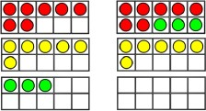
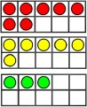
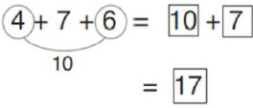
+
231
123
354
COLUMN METHOD—No bridging
Children to use the formal column method to add the ones, tens and then hundreds.

CONCRETE (objects)
ADDING THREE SINGLE DIGITS
3 + 7 + 6 = 16
Look for number bonds to 10 and then see what is leftover.
Use counters on a 10s frame and then move them altogether to aid counting and identifying number bonds.
PICTORIAL
ADDING THREE SINGLE DIGITS
Draw a picture to recombine the objects to make 10 plus how many leftover to create a more efficient statement.

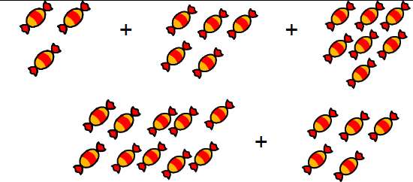

Use a part-whole model to represent the numbers, then draw counters in 10s frames to solve the calculation.
ABSTRACT
ADDING THREE SINGLE DIGITS
Com- the num- that ten (where ble)
add on what is leftover mentally.
bine two bers
make
possi-
and
Skill: Add three 1-digit numbers
Year 2

Base 10 and place value counters are the most effective resources when adding numbers with 3-digits.








PICTORIAL
COLUMN METHOD—No bridging
After practically using the Base 10 and counters, children can draw the counters to help them to solve addition number statements.
231 + 123 = 354
H
T
O
CONCRETE (objects)
COLUMN METHOD—No bridging
Add together the ones first and then the tens and then the hundreds.
Use the Base 10 blocks first before moving onto place value counters.
231 + 123 = 354
Ones
Tens
Hundreds
Hundereds Tens Ones
100 | 100 | 10 | 10 | 10 | 1
 | 100 |  | 10 | 10 | 1 | 1 | 1

+
231
123
354
ABSTRACT part 1
COLUMN METHOD—No bridging
Children to use the expanded column method to add the ones, tens and then hundreds.
200 and 30 and 1
100 and 20 and 3

300 and 50 and 4

ABSTRACT part 2
Children to use the formal column method to add the ones, tens and then hundreds.

Skill: Add numbers with up to 3-digits.
Year 3

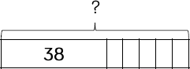
Skill: Add 1 and 2-digit numbers to 100.
Year 2/3
When adding single digits to a 2-digit number, children should count on from the larger number. They should also use their knowledge of num- ber bonds to support their addition.
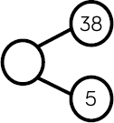
CONCRETE (objects)
Children to use Base 10 to add a 1-digit and a 2-digit number within 100.
38 + 5 = 43
+
Children should spot this
number bond to 10. 8 + 2 = 10
PICTORIAL
Children will begin by using a number line to count on from the greatest number.

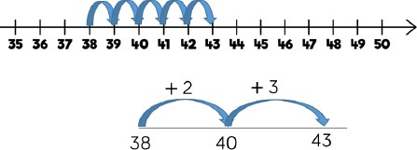

Children will move away from using the physi- cal Base 10 to drawing visual representations.
38 + 5 = 43
ABSTRACT
Children will begin to count up in their heads to solve the calculation. They could picture a Part-Whole model, a number line or a bar model in their heads.

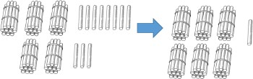
Skill: Add two 2-digit numbers to 100.
Year 2
In Year 2, pupils will become efficient at using Base 10 and Base 10 jottings to add two 2-digit numbers together.
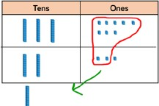
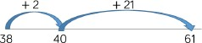
CONCRETE (objects)
Without bridging
This is when the calculation does not bridge 10 and therefore no exchanging is required. Using physical Base 10. 2 + 33 =

With bridging
This is when the calculation bridges 10 and therefore exchanging is required. Using physical Base 10.
23 + 38 =
PICTORIAL
Without bridging
This is when the calculation does not bridge 10 and therefore no exchanging is required. Using Base 10 jot-
tings. 24 + 33 =
With bridging
This is when the calculation bridges 10 and therefore exchanging is required. 23 + 38 =
ABSTRACT
Children can use a blank number line to count on to find the total. Children should be encouraged to jump to multiples of 10 to be- come more efficient.








CONCRETE (objects)
COLUMN METHOD—No Bridging
Add together the ones first and then the tens.
Use Base 10 before moving onto place val- ue counters.
31 + 23 = 54
Ones
Tens
+
231
123
354
Tens Ones
10 | 10 | 10 | 10 | 10 | 1 | 1 | 1 | 1

PICTORIAL
COLUMN METHOD—No bridging
After practically using the Base 10 and counters, children can draw counters in a place value grid to help them to solve addition number state- ments.
31 + 23 = 54
T
O
ABSTRACT part 1
COLUMN METHOD—No bridging
Children to use the expanded column method to add the units/ones and then the tens.
30 and 21
20 and 3

50 and 4

ABSTRACT part 2
COLUMN METHOD—NO REGROUPING
(no carrying down)
Children to use the formal column method to add the units/ones and then the tens.
In Year 3, pupils are encouraged to use the formal column method alongside Base 10 or place value counters until they fully understand and can explain the process. As numbers become larger, Base 10 and place value counters become less efficient.

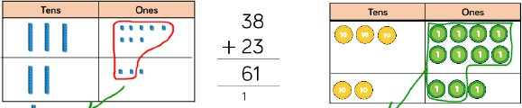
CONCRETE (objects)
COLUMN METHOD—Bridging
Make both numbers on a place value grid.

Add the ones and exchange ten ones for one tens stick.
Add up the rest of the columns, until every column has been added.

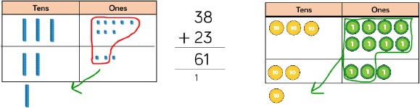

Place value counters can also be used to show this.
ABSTRACT part 1
COLUMN METHOD—Bridging
Start by partitioning the numbers before moving on to clearly show the exchanging.
20 + 5
40 + 8

70 + 3

10
ABSTRACT part 2
Children to use the formal column method to add the ones and then the tens, showing exchanging.
T | O




T | O

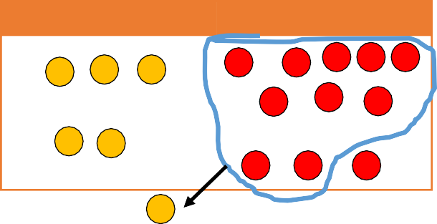
PICTORIAL
COLUMN METHOD—Bridging
Children can draw a pictorial representation of the columns and objects to further support their understanding.
This is a quicker and more efficient way than using the coun- ters if they are secure with what the exchanging means.
38 + 23 = 61
Exchange these
ones for a 10.
+
1
25
48
73
In Year 3, pupils are encouraged to use the formal column method alongside Base 10 or place value counters until they fully understand and can explain the process. As numbers become larger, Base 10 and place value counters become less efficient.

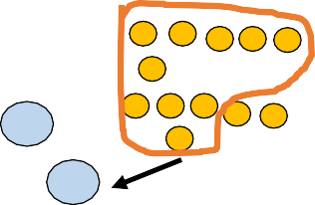
Skill: Add numbers with up to 3-digits.
Year 3
PICTORIAL
COLUMN METHOD—Bridging
After practically using Base 10 and counters, chil- dren can draw the counters to help them to solve addition number statements.
265 + 164 = 429
H
T
O
It could also be represented in a bar model.
Base 10 and place value counters are the most effective practical resources when adding numbers with 3-digits.
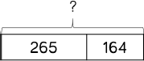
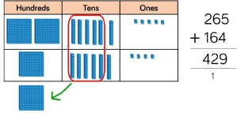
1 1 1
759
486
1245
+
ABSTRACT
COLUMN METHOD—Bridging
The children would then move onto using the column addition without any physical ob- jects or pictorial representations.
CONCRETE (objects)
COLUMN METHOD— Bridging
Make both numbers on a place value grid.

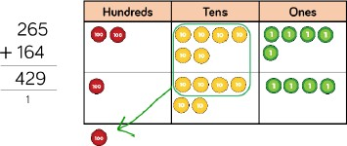
Add the ones and exchange ten ones for one ten if needed. Then repeat for the tens and hundreds columns.
Add up the rest of the columns, until every
column has been added.

Base ten can also be used to show this.

Skill: Add with up to 4-digits
Year 4
The children will begin adding numbers with up to 4-digits with calculations that contain no bridging. They will follow the same methods as in Year 3 but with a thousands column. After this, they will move onto bridging the ones, tens, hundreds or thousands.
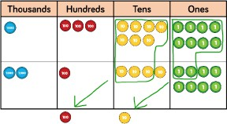
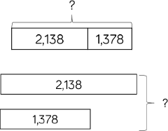
+
1 1 1
5759
3486
9245
ABSTRACT
COLUMN METHOD— Bridging
The children then move onto using the col- umn addition without any physical objects or pictorial representations.
CONCRETE (objects)
COLUMN METHOD— Bridging
Make both numbers on a place value grid.
Add the ones and exchange ten ones for one ten if needed. Then repeat for the tens, hundreds and thousands columns.
Add up the rest of the columns, until every column has been added.
PICTORIAL
COLUMN METHOD— Bridging
After practically using the Base 10 and counters, children can draw the counters (jottings) to help them to solve addition number statements. See the previous page (Year 3) for a similar example. The place value grid would have a thousands col- umn.
The children can also represent, and solve, their calculation using a bar model. They could then add the ones, tens, hundreds and thousands to- gether using jottings (as mentioned above).

Skill: Add with more than 4-digits.
Years 5 & 6
At this stage, children should be encouraged to use the concrete and pictorial method a handful of times so that they can visually see the process and then they should be encouraged to work in the abstract. This is because using the column method is the most efficient when adding larger numbers.
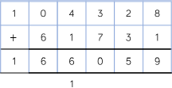
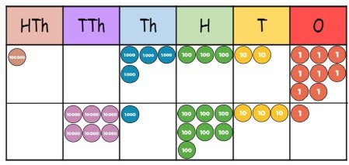
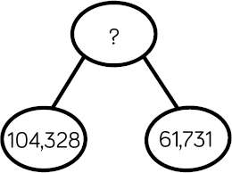
1
ABSTRACT
The children should be encouraged to use the column method. They will need to ensure that they lay out their calculations in the cor- rect columns to avoid any mistakes.
CONCRETE (objects)
Place value counters or plain counters on a place value grid are the most effective con- crete resources when adding numbers with more than 4 digits.
For example,
104,328 + 61,731 = 166,059
PICTORIAL
Children can draw a bar model to help them visualise the calculation that they are solving.

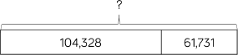

They could also draw a part-whole model.

Place value counters on a place value grid are the most effective resources when adding numbers with 1, 2 and then 3 decimal places. Chil- dren must have experiences of adding decimals in a variety of contexts including measures and money.
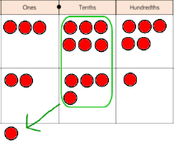
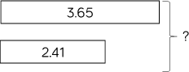
1
57.50
+3.48
60.98

ABSTRACT
Once children understand the concept of adding decimals, then they can use the col- umn method.

It is important that they ensure the decimal points are in line, regardless of how many ‘numbers’ are before/after the decimal point.
CONCRETE (objects)
Children should begin by adding numbers with one decimal place, then 2 and 3 deci- mal places.
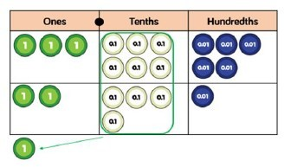
As well as place value counters, children could also use plain counters. This makes the transition to pictorial more seamless.
PICTORIAL
Children can begin by drawing place value grids and counters to support their developing calcu- lation skills.

Children will then move onto drawing a bar mod-
el to help them visualise the calculation.

Skill: Add with up to 3 decimal places.
Years 5 & 6

Skill | Year Group(s) | Representations and models
Subtract two 1-digit num- bers within 10 | 1 | Objects, Numicon, tens frames (within 10), part-whole model, number line (labelled), bead strings (10)
Subtract 1 and 2-digit numbers to 20. | 1 | Objects, Numicon, tens frames (within 20), part-whole model, number line (labelled), straws.
Subtract 1 and 2-digit  numbers to 100 | 2 | Part-whole model, bar model, number lines (labelled), straws, jottings, Base 10.
Subtract two 2-digit num- bers. | 2 & 3 | Part-whole model, bar model, number lines (blank), hundred square, Base 10, jottings, bar model, col- umn subtraction.
Subtract numbers with up to 3-digits. | 3 | Part-whole model, bar model, Base 10, place value counters, column subtraction.
Subtract numbers with  up to 4-digits. | 4 | Part-whole model, bar model, Base 10, place value counters, column subtraction.
Subtract numbers with more than 4-digits. | 5 | Part-whole model, bar model, Base 10, place value counters, column subtraction.
Subtract numbers with to 3 decimal places. | 5 & 6 | Part-whole model, bar model, place value counters, column subtraction.

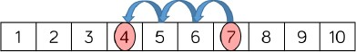
Part-whole models, tens frames, bar models and Numicon support the partitioning of numbers. Tens frames, number lines and single bar models support reduction.

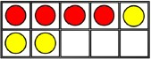
CONCRETE (objects)
Partitioning
Children can use Numicon to partition the number they are subtracting.
7—3 =
Reduction
This is when the children ‘take away’ an amount. Make the larger number with the beads and then slide the beads along as you count back in ones.

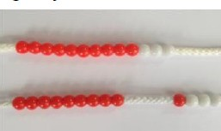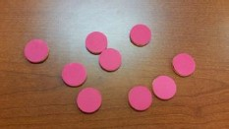

Alternatively, use counters and move them away from the group as you take away, counting backwards out loud as you do.
PICTORIAL
Partitioning
The next step is to move onto using a tens frame or a labelled number line.
With a tens frame, you draw the greatest number and subtract (cross out) the smallest number.

Reduction
With a number line, you start on the greatest number and jump backwards by the amount you are subtracting.
ABSTRACT
Partitioning
Children confident in counting back mental- ly in ones by recognising symbols and read- ing mathematical statements:

E.g. 18—6 = 12
8—5 = 3

Reduction
Children confidently count back mentally.
Children may use their fingers for visual sup- port.

Skill: Subtract two 1-digit numbers within 10.
Year 1

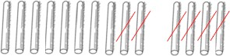
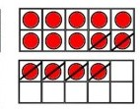
When subtracting 1-digit numbers that cross 10, it is important to highlight the importance of one ten equaling ten ones.
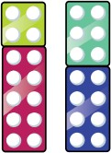
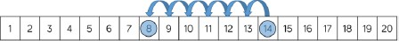
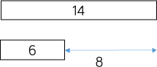
CONCRETE (objects)
Partitioning
Children can use Numicon to partition the number they are subtracting.
14—6 = 8

Reduction
Use counters or straws and move them away from the group as you take away, counting backwards out loud as you do.
PICTORIAL
Partitioning
The next step is to move onto using a tens frame or a labelled number line.
With two tens frame, you draw the greatest number and subtract (cross out) the smallest number.

Reduction
With a number line, you start on the greatest number and jump backwards by the amount you are subtracting.
ABSTRACT
Children use their knowledge to solve word problems based on finding the difference or comparing two numbers.
They may find is useful to picture a bar model to visualise the calculation.

Skill: Subtract 1 and 2-digit numbers to 20.
Year 1

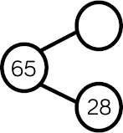
Skill: Subtract 1 and 2-digit numbers to 100
Year 2
At this stage children will be using Base 10 to support their calculation skills. As numbers become larger straws become much less efficient. Children should be encouraged to count in multiples of 10 to become more efficient.
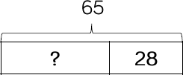
CONCRETE (objects)
Children to use Base 10 to subtract a 1-digit and a 2-digit number within 100.
38 - 5 = 33

Children physically move the Base 10 away from the group so that they can see that the number is removed. Then the children count how many are left.
PICTORIAL
Children will begin by using a number line to count on from the smallest number.

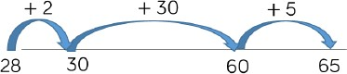

Children will move away from using the physi- cal Base 10 to drawing visual representations. They cross out the number that they need to subtract.
38 - 5 = 33
ABSTRACT
Children will begin to count back in their heads to solve the calculation. They could visualise a Part-Whole model, a number line or a bar model in their heads.

Children should learn how to complete the column method in the concrete stage. This skill should be really embedded before moving onto pictorial and abstract methods.
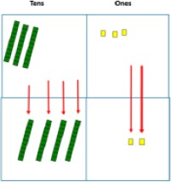
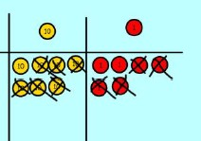
3 1
42
23
22
-_
CONCRETE (objects)
COLUMN METHOD WITHOUT REGROUPING
Use Base 10 to physically make the larger number and then take away the smallest number.
Count what is leftover using tens and
units knowledge. E.g.
75—42 = 33
PICTORIAL
COLUMN METHOD WITHOUT REGROUPING
Draw the Base 10 or Place Value counters and cross them out to take away.
ABSTRACT
COLUMN METHOD WITHOUT REGROUPING
Partition the numbers to show place value and use the expanded column method.
40 and 5
-
20 and 3

20 and 2

This will lead to a more formal column method
when knowledge of place value is secure.

Children should learn how to complete the column method in the concrete stage. This skill should be really embedded before moving onto pictorial and abstract methods.
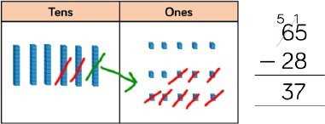
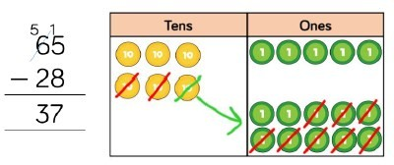
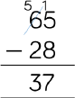
CONCRETE (objects)
COLUMN METHOD WITH REGROUPING
Use Base 10 to start with before moving on to place value counters. Start with one ex- change.
Always start with the units/ones
PICTORIAL
COLUMN METHOD WITH REGROUPING
Draw Base 10 or place value counters onto a place value grid and show what you have taken away by crossing out as well as showing the ex- changes you have made.
ABSTRACT
COLUMN METHOD WITH REGROUPING
Partition the numbers to show place value and use the expanded column method to show ex- changing by crossing out the original numbers.
60 + 5
- 20 + 8
—————- 50 + 15
- 20 + 8
————— 30 + 7

Children are to use the formal column method to sub- tract the ones and then the tens, showing exchanging.

Skill: Subtract numbers with up to 3-digits.
Year 3
Base 10 and place value counters are the most effective resource when subtracting larger numbers. It is important to ensure that children write out their calculation alongside any concrete resources so that they can see the link between the concrete and abstract methods.
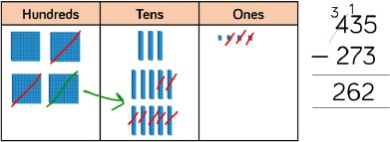
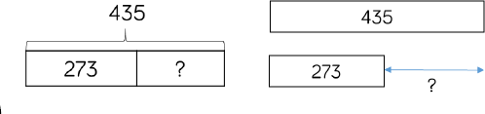
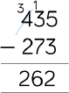
CONCRETE (objects)
Children begin by using Base 10 to practi- cally solve the subtraction calculations. They should write the column method calculation alongside the physical resources.
435—273 = 262

Children begin by making the largest (first) number. Then they move out the number of ones, tens and then hun- dreds that they are subtracting. Ex- changing is to occur as and when it is needed.
PICTORIAL
After practically using Base 10 and counters, chil- dren can draw the counters to help them to solve subtraction number statements.
435—273 = 262

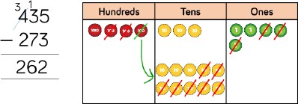

It could also be represented in a bar model.
ABSTRACT
The children then move onto using the col- umn addition without any physical objects or pictorial representations.

Skill: Subtract with up to 4-digits.
Year 4
The children will subtract numbers with up to 4-digits with calculations that contain no bridging. They will follow the same methods as in Year 3 but with a thousands column. After this, they will move onto bridging the ones, tens, hundreds or thousands.
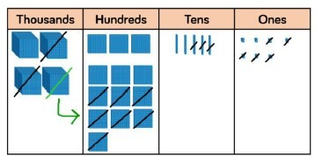
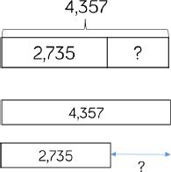
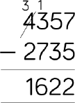
CONCRETE (objects)
Make the largest number on a place value grid.
Subtract the ones and exchange ten ones for one ten if needed. Then repeat for the tens, hundreds and thousands columns.
Add up the remaining pieces to Base 10 to get the answer.
4,357—2,735 =1,622
PICTORIAL
After practically using Base 10 and counters, chil- dren can then draw the counters (jottings) to help them to solve addition number statements. See the previous page (Year 3) for a similar example. The place value grid would have a thousands col- umn.
The children can also represent, and solve, their calculation using a bar model. They could then subtract the ones, tens, hundreds and thousands together using jottings (as mentioned above).
ABSTRACT
The children then move onto using the col- umn subtraction without any physical objects or pictorial representations.

Skill: Subtract numbers with more than 4-digits.
Years 5 & 6
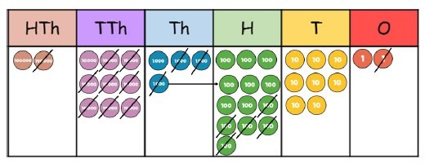
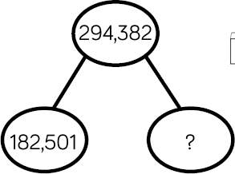
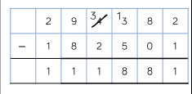
CONCRETE (objects)
Place value counters or plain counters on a place value grid are the most effective con- crete resources when subtracting numbers with more than 4 digits.
For example,
294,382—182,501 = 11,881
PICTORIAL
Children can draw a bar model to help them visualise the calculation that they are solving.

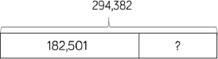

They could also draw a part-whole model.
ABSTRACT
The children should be encouraged to use the column method. They will need to ensure that they lay out their calculations in the cor- rect columns to avoid any mistakes.
At this stage, children should be encouraged to use the concrete and pictorial method a handful of times so that they can visually see the process and then they should be encouraged to work in the abstract. This is because using the column method is the most efficient when sub- tracting larger numbers.

Skill: Subtract numbers with to 3 decimal places.
Year 5 & 6
Place value counters on a place value grid are the most effective resources when subtracting numbers with 1, 2 and then 3 decimal places. Children must have experiences of adding decimals in a variety of contexts including measures and money.
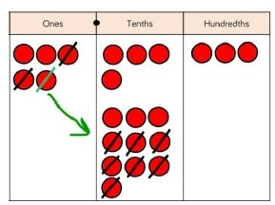
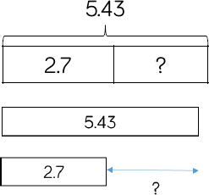
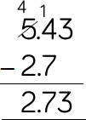
0
CONCRETE (objects)
Children should begin by subtracting num- bers with one decimal place, then 2 and 3 decimal places.
5.43—2.7 = 2.73

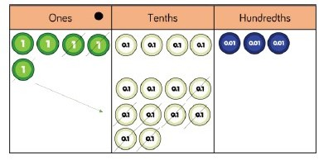
As well as place value counters, children could also use plain counters. This makes the transition to pictorial more seamless.
PICTORIAL
Children can begin by drawing place value grids and counters to support their developing calcu- lation skills.
5.43—2.7 = 2.73

Children will then move onto drawing a bar mod- el to help them visualise the calculation.
ABSTRACT
Once children understand the concept of subtracting decimals, then they can use the column method.

It is important that they ensure the decimal points are in line, regardless of how many ‘numbers’ are before/after the decimal point.

Skill | Year Group(s) | Representations and models
Solve one-step problems with multiplication. | 1/2 | Bar model, Numicon, counters, tens frames, arrays.
Multiply 2-digit numbers by 1-digit numbers | 3/4 | Place value counters, Base 10, short written method, expanded written method.
Multiply 3-digit numbers | 4 | Place value counters, Base 10, short written method.
Multiply 4-digit numbers by 1-digit numbers. | 5 | Place value counters, short written method.
Multiply 2-digit numbers by 2-digit numbers. | 5 | Place value counters, Base 10, short written method, grid method.
Multiply 2-digit numbers | 5 | Place value counters, short written method, grid method.
Multiply 2-digit numbers by 4-digit numbers. | 5/6 | Formal written method.

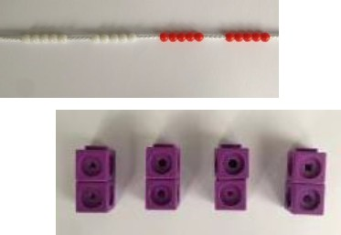
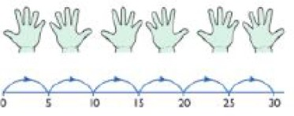
Before moving on to solve multiplication problems, children should become confident with doubling and practically counting in multiples.
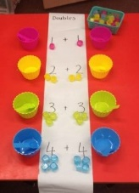
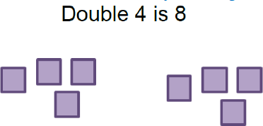
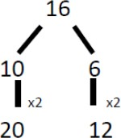
CONCRETE (objects)
DOUBLES
Use practical activities to model how to double a number.
E.g cubes, counters, pencils, people etc.

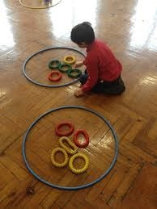

COUNTING IN MULTIPLES
Count in multiples supported by concrete objects in equal groups.
PICTORIAL
DOUBLES
Draw pictures to show how to double a number.

COUNTING IN MULTIPLES
Use a number line or pictures to continue support in counting in multiples.
ABSTRACT
DOUBLES
Partition the number and then double each part before recombining it back together.

COUNTING IN MULTIPLES
Count in multiples of a number out loud. Write sequences with multiples of numbers.

2, 4, 6, 8, 10
5, 10, 15, 20, 25

Skill: Doubling numbers and counting in multiples.
Years 1 & 2

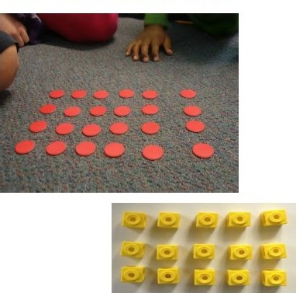
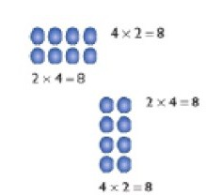
Children represent multiplication as repeated addition in many different ways. In Year 1, children use concrete and pictorial representations to solve problems. In Year 2, children are expected to record multiplication formally as number sentences.
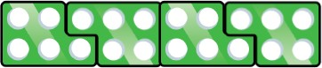

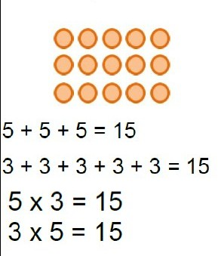
CONCRETE (objects)
Children use Numicon (with support) to get the right amount of groups and then count the total in multiples.

They then move onto moving counters into groups.

Children then move these counters into arrays to solve multiplication number sentences.
PICTORIAL
In Year 1, children draw the number of groups (large circles) and then draw the cor- rect number of counters in each group.

In Year 2, children draw arrays in different ro- tations to find commutative multiplication sentences.
ABSTRACT
In Year 1, children write addition number sen- tences to match objects or pictures

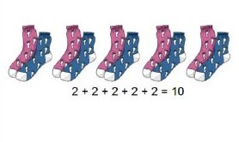
In Year 2, children use an array to write multi- plication sentences.

Skill: Solve one-step problems with multiplication
Years 1 & 2

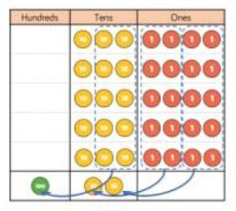
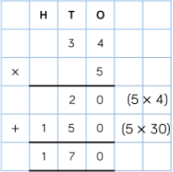
Skill: Multiply 2-digit numbers by 1-digit numbers.
Years 3 & 4
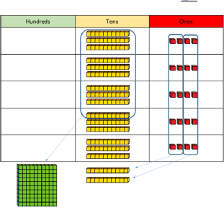
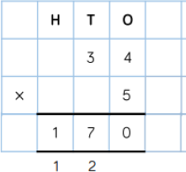
1 2

CONCRETE (objects)
Expanded column method
34 X 5 = 170
Children begin using Base 10 to get 5 groups of 34. They then count the ones and tens and exchange 10 ones for a 10s stick and 10 tens sticks for a hun-
dred.
Then they can count the Base 10 to solve the answer to the calculation.
Short Multiplication Method
During the concrete stage this method fol- lows the same rules as above but can be solved using place val- ue counters.
PICTORIAL
Children can draw a pictorial representation of the concrete method. This is a ‘stepping stone’ method and can initially be used alongside the abstract method to support understanding.
ABSTRACT
Expanded column method
Children begin by writing the calculation. Under- neath this, they write the two number sentences that they will need to solve and write the answers.
They then use column ad- dition to find the answer.
Short Multiplication Method
This method directly follows on from the expand- ed column method, Children will solve the multi- plication number sentences mentally.
E.g. 5 X 4 = 20 (carry the 2)
5 X 3 = 15 (add the 2 that you carried)
Children will look at the expanded column method before moving onto the short multiplication method. The place value counters should be used to support the understanding of the method rather than supporting the multiplication, as the children should use times table knowledge to support their learning.

Skill: Multiply 3-digit numbers by 1-digit numbers.
Year 4
Children should be encouraged to move towards the short, formal written method. Base 10 and place value counters can be used to support during the concrete phase.
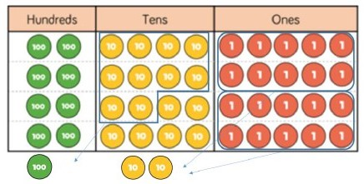
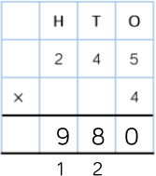

1 2
CONCRETE (objects)
Short column method
295 x 4 = 980
Children begin using Base 10 or place value counters. They then count the ones and tens and exchange 10 ones for a 10s stick and 10 tens sticks for a hundred.
Then they can count the Base 10 or counters to solve the answer
PICTORIAL
Children can draw a pictorial representation of the concrete method. This is a ‘stepping stone’ method and it can initially be used alongside the abstract method to support understanding.
ABSTRACT
Short Multiplication Method
This method directly follows on from the ex- panded column method, Children will solve the multiplication number sentences mental- ly.
For example, 295 x 4 = 980
5 x 4 = 20 (carry the 2)
4 x 4 = 16 + 2 (that you carried) = 18 (carry
the 1)
4 x 2 = 8 + 1 (that you carried) = 9

Skill: Multiply 4-digit numbers by 1-digit numbers.

When multiplying 4-digit numbers, place value counters are the best resource that children can use to support their understanding of the for- mal written method. If children are multiplying larger numbers and struggling with their times tables, encourage them to use a multiplication grid so that they can focus on the method.
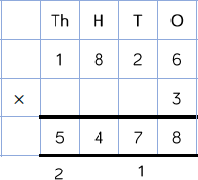
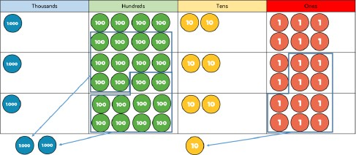
ABSTRACT
Formal Method
This method directly follows on from the ex- panded column method, Children will solve the multiplication number sentences mental- ly.
1,826 x 3 = 5,478

2 1
CONCRETE (objects)
1,826 x 3 = 5,478
Children begin using place value coun- ters. They partition the number into thou- sands, hundreds, tens and ones. They then make any required exchanges. Fi- nally, they add up the ones, tens, hun- dreds and thousands to solve the calcu- lation.
PICTORIAL
Children can draw a pictorial representation of the concrete method. This is a ‘stepping stone’ method and can it initially be used alongside the abstract method to support understanding.

When multiplying 2-digit numbers by 2-digit numbers. The area grid method can be used to help children understand the size of the numbers they are working with. The grid method then matches the area grid method and it is an initial written method.
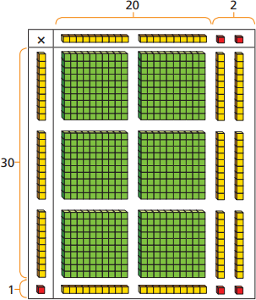
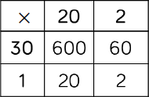
Skill: Multiplying 2-digit numbers by 2-digit numbers.
Multiply 2-digit by 3-digit numbers Year 5
ABSTRACT
Formal Written Method
This method follows on from the grid method. Children will solve the multiplication number sentences mentally.
22 x 31 = 682

 | 2 | 2
x | 3 | 1
 | 2 | 2
6 | 6 | 0
6 | 8 | 2

Children should be remind that they need to use a place holder and understand why this is the case.
CONCRETE (objects)
22 x 31 = 682
Partition both 2-digit numbers and then multiply them together.

The Base 10 is useful to help children think about the size of the numbers they are working with.
PICTORIAL
Following on from the area grid method, chil- dren will move towards using the grid meth- od.
This method is much more efficient yet it is still a more ‘visual’ method than the formal method.
22 x 31 = 682

34

1 1 5 2 1 7
ABSTRACT
Formal Written Method
The layout for this needs to be taught explicitly as it can lead to errors being made. Children should always use squared paper when laying out calculations.
Considerations should be made for where exchanged digits are places and ensure that this is consistent.

 | 2 | 7 | 3 | 9
x |  |  | 2 | 8
2 | 1 | 9 | 1 | 2
5 | 4 | 7 | 8 | 0
7 | 6 | 6 | 9 | 2

When multiplying 4-digit numbers by 2-digit numbers the children should already be confident in using the formal written method.

Skill: Multiply 4-digit numbers by 2-digit numbers.
Year 5 & 6

Skill | Year Group(s) | Representations and models
Solve one-step problems with division. | 1/2 | Bar model, objects, arrays, counters, Numicon, number lines.
Divide 2-digit numbers by 1- digit (no exchange sharing) | 3 | Straws, Base 10, bar model, place value counters, part-whole model.
Divide 2-digit numbers by 1- digit numbers (sharing with remainders) | 3/4 | Objects, place value counters, counters, number line, part-whole model.
Divide 2-digit numbers by 1-  digit (grouping) | 4/5 | Place value counters, counters, place value grid, short division.
Divide 3-digits numbers by 1  -digit (sharing with ex- change) | 4 | Base 10, bar model, place value counters, part-whole model.
Divide 3-digit numbers by 1- digit (grouping) | 4/5 | Place value counters, counters, place value grid, short division.
Divide 4-digit numbers by 1- digit (grouping) | 5 | Place value counters, counters, place value grid, short division.
Divide multi-digit numbers by 2-digits (short division) | 6 | Written long division, list of multiples.
Divide multi-digit numbers by 2-digits (long division) | 6 | Written long division, list of multiples.

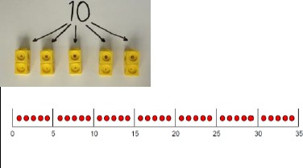
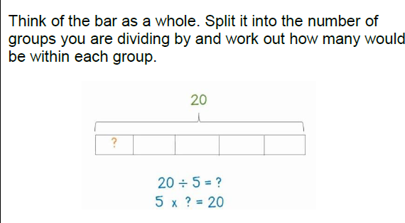
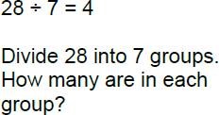
To begin with, children should solve problems by sharing amounts into equal groups. In Year 1, children use concrete and pictorial
representa tions to solve problems. In Year 2, children are expected to use a more abstract approach and record their own number sentences.
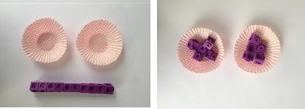
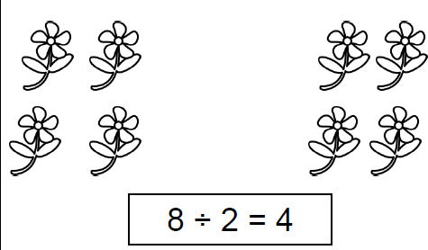
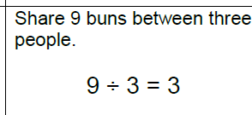
CONCRETE (objects)
SHARING INTO GROUPS
Use objects to share amounts into equal groups. E.g. I have ten cubes, can you share them into two equal groups?

DIVISION AS GROUPING
Divide quantities into equal groups.
Use cubes, counters or any other objects to
support understanding.
PICTORIAL
SHARING INTO GROUPS
Children use pictures or shapes to share quantities equally.

DIVISION AS GROUPING
Use a number line to show jumps in groups. The number of jumps equals the number of groups.
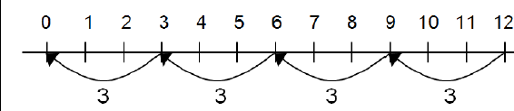
Also use the bar model to show number of groups within a number as a total.
ABSTRACT
SHARING INTO GROUPS
Solving problems and using the correct symbols to show division by sharing.

DIVISION AS GROUPING
Solving problems and using the correct symbols to show division by grouping.

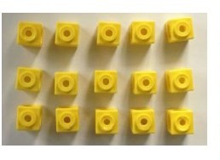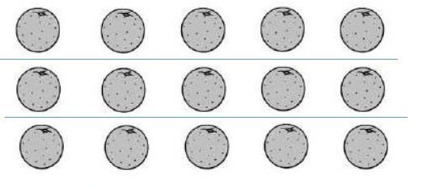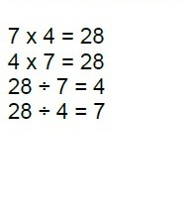
CONCRETE (objects)
DIVISION WITIHIN ARRAYS (INVERSE)
Link division to multiplication by creating and array and thinking about the number sentences that can be made from it.
E.g.
3 x 5 = 15
5 x 3 = 15
15 ÷ 3 = 5
15 ÷ 5 = 3
PICTORIAL
DIVISION WITIHIN ARRAYS (INVERSE)
Draw an array and use lines to split the array into groups to make multiplication and division sentences.
ABSTRACT
DIVISION WITIHIN ARRAYS (INVERSE)
Find the inverse of multiplication and division sentences by finding all 4 possibilities.

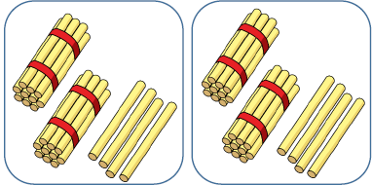
PICTORIAL
Once children are confident using the physi- cal Base 10 resource they can then move on- to drawing jottings or arrays.
24 ÷ 2 = 12
With an array
With Base 10 jottings
Skill: Divide 2-digits by 1-digit (sharing with no exchange)
Year 3
When dividing larger numbers, children can use concrete objects to allow them to partition numbers into tens and ones.
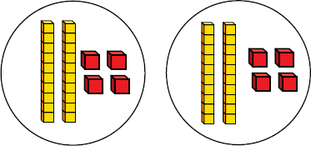
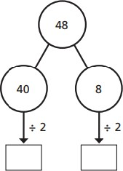
CONCRETE (objects)
Children can use straws and Base 10 to create groups of tens and ones. They can then share these equally into the correct number of groups.
For example,
48 ÷ 2 = 24
 |  |  |  |  |  |  |  |  |  | 
 |  |  |  |  |  |  |  | 

ABSTRACT
To support children to solve the calculation without pictorial or concrete representations children can use a part-whole model.
Children partition the number they are divid- ing and then divide those numbers before combing them back together at the end to get the answer.

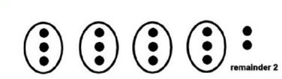
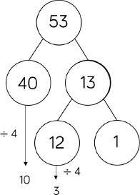
Skill: Divide 2-digits by 1-digit numbers (sharing with remainders)
Years 3 & 4
When dividing numbers with remainders, children can use Base 10, objects and place value counters to support children’s initial understand- ing. Starting with equipment outside of the grids allows them to see the remainders more easily.
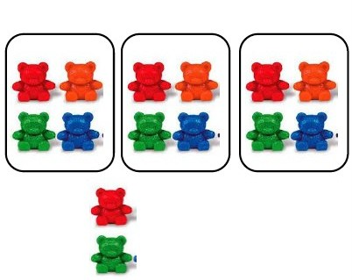
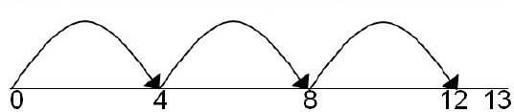
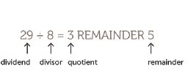
CONCRETE (objects)
DIVISION WITH A REMAINDER
Divide objects between groups and see how much is left over.

14 ÷3 = 4 r 2
PICTORIAL
DIVISION WITH A REMAINDER
Jump forward in equal jumps on a number line and then see how many more you need to find the remainder.

Alternatively or in addition to, draw dots and group them to divide an amount and clearly show a remainder.
ABSTRACT
DIVISION WITH A REMAINDER
As with the previous skill, children can use a part- whole model to partition the number they are di- viding. Then they can divide those numbers and ascertain how many remainders there are.

Complete written divisions and show the remain- der using ‘r’.

When using the short division method, children use grouping. Starting with the largest place value, they groups by the divisor. Using the correct vocabulary is really important. “How many groups of 4 tens can we make?”
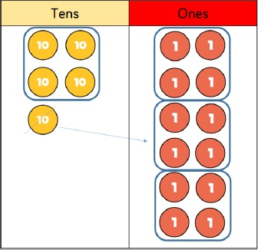
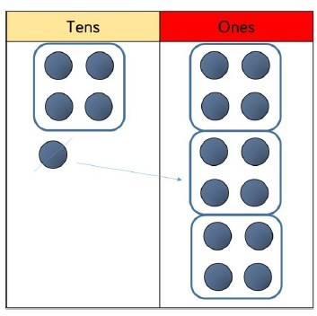
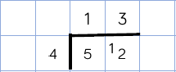
CONCRETE (objects)
Using place value counters to ‘group’ is the first step towards using the short method for division.
52 ÷ 4 = 13
PICTORIAL
The next step is to draw ‘counters’ into a place value grid and make annotations. This follows the concrete method very closely.
52 ÷ 4 = 13
ABSTRACT
Begin with divisions where there are no remain- ders.

Children start with the tens.
How many times does 4 go into 5? 1 with 1 re- mainder. Write this remainder next to the ones digit.
How many times does 4 go into 12? 3 with no re- mainders.
Skill: Divide 2-digits by 1-digit (grouping).
Years 4 & 5

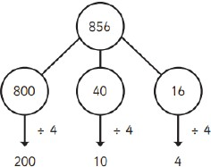
PICTORIAL
Children are to begin by drawing a bar mod- el. This allows them to visualise the calcula- tion.
856 ÷ 4 = 214
After this, they can complete a part-whole
model.
Skill: Divide 3-digits by 1-digit (sharing with exchange)
Year 4
Children should continue to use place value counters to divide 3-digit numbers. They should start with equipment outside of the grids as this allows remainders to be clearly highlighted.
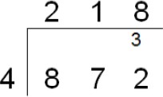
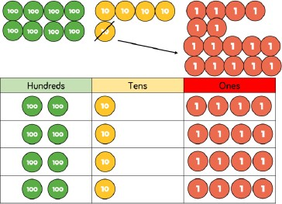
ABSTRACT
Begin with divisions where there are no remain- ders.

I start by thinking, does 4 go into 8? Yes, two times.
Write 2 on top of the line.
Now does 4 go into 7? Only once and there are 3 left over so write 1 and carry the 3 over to the 2.
Does 4 go into 32? Yes, 4 8 times so I write 8 above the line.
The answer is 218.
CONCRETE (objects)
Children to make the 3-digit number that they are sharing with place value counters (or Base 10). They place this number outside of a place value grid. They then share the hundreds, tens and ones. If there are any hundreds or tens left over they can be ex- changed. If there are any ones left over they are the remainders.
856 ÷ 4 = 214
856
? | ? | ? | ?

Skill: Divide 3-digits by 1-digit (grouping)
Years 4 & 5
Children can continue to use grouping to support their understanding of short division.
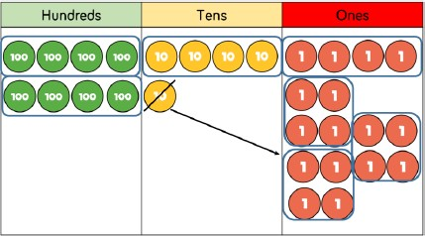
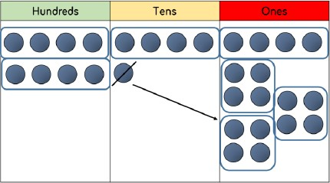
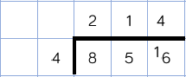
CONCRETE (objects)
Children to make the 3-digit number that they are sharing with place value counters (or Base 10).
They partition the number they are dividing into the grid. They then draw groups around the number they are dividing by.
856 ÷ 4 = 214
PICTORIAL
Children to draw the 3-digit number that they are sharing into a place value grid.
They partition the number they are dividing into the grid. They then draw groups around the num- ber they are dividing by.

856 ÷ 4 = 214
ABSTRACT
Begin with divisions where there are no remain- ders. Children start with grouping the hundreds, then tens and then finally the ones digit.

Skill: Divide 4-diigits by 1-digit (grouping)
Year 5
Children can continue to use grouping to support their understanding of short division.
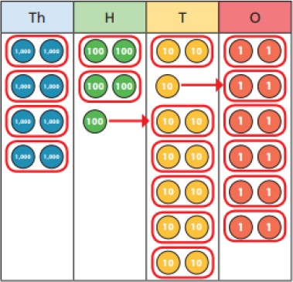
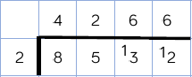
CONCRETE (objects)
Children to partition the 4-digit number that they are sharing with place value counters (or Base 10).
They partition the number they are dividing into a place value grid. They then draw groups around the number they are dividing by.
8,532 ÷ 2 = 4,266
PICTORIAL
Children to draw the 4-digit number that they are sharing into a place value grid.
They partition the number they are dividing into the grid. They then draw groups around the num- ber they are dividing by.
This step will mirror the concrete approach but it will use jottings/drawings rather than the physical objects.
ABSTRACT
Begin with divisions where there are no remain- ders. Children start with grouping the thousands, then the hundreds, tens and then finally the ones digit.

When children begin to divide up to 4-digit numbers by 2-digits, written methods become the most accurate and effective method.
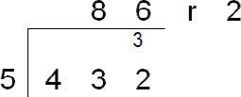
ABSTRACT
Begin with divisions where there are no remainders.

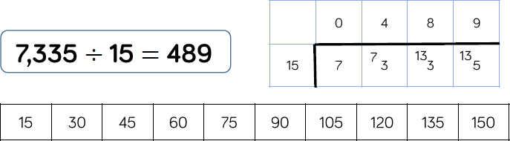
I start by thinking, does 5 go into 4? No Carry the 4 over to the 3 to create 43.
Now does 5 go into 43? Yes, 8 times with 3 leftover. Write the 8 above the line and carry over the 3.
Does 5 go into 32? Yes, 6 times with a remainder of 2. The answer is 86 r2.
Skill: Divide multi-digits by 2-digits (short division)
Year 6

ABSTRACT
Start with calculations that have no remainders.

432 ÷ 12 = 36
To support their use of this method children should write down the multiplication table at the side of the method.
 |  | 0 | 3 | 6
1 | 2 | 4 | 3 | 2
 |  | 3 | 6
 |  | 0 | 7 | 2
 |  |  | 7 | 2
 |  |  | 0 | 0
‘How many 12s go into 43?’ 12 x 3 = 36.
43– 36 = 7.
Move down 2.
‘How many 12s go into 72?’ 12 x 6 = 72
72—72 = 0.

 |  | 0 | 4 | 8 | 9
1 | 5 | 7 | 3 | 3 | 5
 |  | 6 | 0
 |  | 1 | 3 | 3
 |  | 1 | 2 | 0
 |  | 0 | 1 | 3 | 5
 |  |  | 1 | 3 | 5
 |  |  | 0 | 0 | 0

7,335 ÷ 15 = 489
‘How many 15s go into 73?’ 15 x 4 = 60
73—60 = 13.
Move down 3
‘How many 15s go into 133?’ 15 x 8 = 120
133—120 = 13.
Move down 5
‘How many 15s go into 135?’ 15 x 9 = 135
135—135 = 0

Skill: Divide multi-digits by 2-digits (long division)
Year 6

