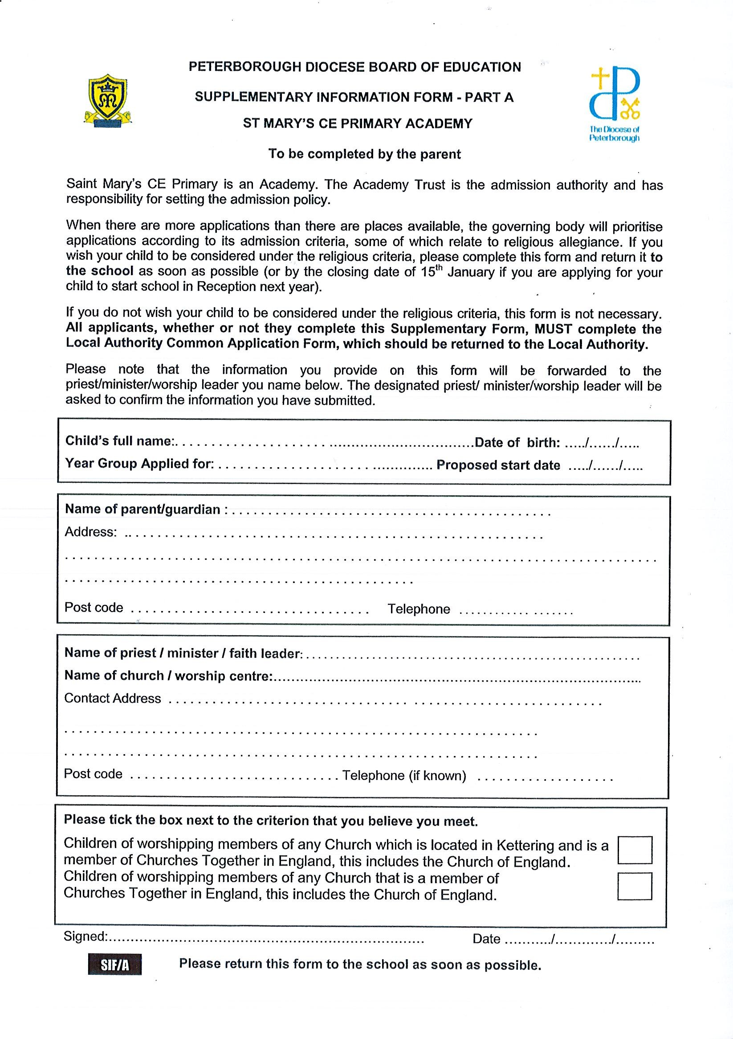

Name of Priest/Minister/FaithLeader………………………………………………………………………………………………………
Name of Church/Worship Centre…………………………………………………………………………………………………………...
Contact Address ………………………………………………………………………………………………………………………………………………………………..
………………………………………………………………………………………………………………………………………………………………..
Postcode………………………………………... Telephone number (if known)………………………………………………………..
Name of parent/Guardian……………………………………………………………………….Address…………………………………………………
…………………………………………………………………………………………………………………………………………………………………
………………………………………………………………………………………………………………..Postcode………………………..........

Child’s full name………………………………………………………………………………………DOB…………/………/……………
Year group applied for………………………Proposed start date……………………………………………………………….


