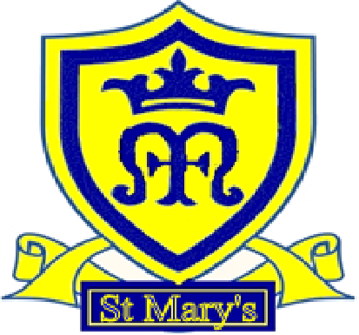
St Mary's CEVA Primary School
School Uniform: policy and procedure

Adopted: Aug 24 Reviewed: April 26
Next review April 28

Our policy has been created in line with ‘Flourishing for all, ‘Fruits of the Spirit Character Education’ and the ‘Church of England’s Vision for Education: Deeply Christian; Serving the common good’. Staff and governors have been made aware of these documents which form the foundation for the school’s ethos, decision-making process and policy design.

We have also carefully considered and analysed the impact of this policy on equality and the possible implications for pupils with protected characteristics, as part of our commitment to meet the Public Sector Equality Duty (PSED) requirement to have due regard to the need to eliminate discrimination, advance equality of opportunity and foster good relations.

Introduction

It is our school policy that all children wear school uniform when attending school, or when participating in a school-organised event outside normal school hours. Children can wear uniform with the school logo or plain coloured uniform. The logo uniform can be ordered from our uniform suppliers via the link on our website. If parents request delivery to the school they will not normally have to pay a delivery charge.

Aims and objectives

Our policy on school uniform is based on the notion that school uniform:

•promotes a sense of pride in the school;
•engenders a sense of community and belonging towards the school;
•is practical and smart;
•identifies the children with the school;
•prevents children from coming to school in fashion clothes that could be distracting in class;
•makes children feel equal to their peers in terms of appearance;
•is regarded as suitable wear for school and good value for money by most parents;
•is designed with health and safety in mind.

Jewellery

On health and safety grounds we do not allow children to wear jewellery in our school. The exceptions to this rule are:
- Earring studs in pierced ears. One only in the bottom of the lobe
- Small objects of religious significance, such as a crucifix on a chain or Sikh Kara We ask the children to remove these objects during PE, games and swimming for health and safety reasons and they must be able to remove them themselves.The school advises parents who wish their children to have their ears pierced to do so at the beginning of the school holidays.
- Medical identification bracelets may be worn by children who have significant medical problems eg. Diabetes or epilepsy.

Extreme haircuts

The school does not permit children to have ‘extreme’ haircuts that could serve as a distraction to other children.

Hairstyles and haircuts which are deemed too extreme such as tramlines, stars, shaved heads (No shorter than a number 2), extreme patterns ‘V’ styles, Mohican cuts, or dyed, tipped or dipped hair are also forbidden. Pupils with long hair should also tie it back for safety reasons.

Footwear

The school wants all children to grow into healthy adults. We believe that it is dangerous for children to wear shoes that have platform soles or high heels, so we do not allow children to wear such shoes in our school. We require all children to wear completely black shoes or trainers, without obvious logos, in keeping with the smart appearance of a school uniform.

Children coming to school during the winter months who wear boots should bring with them black school shoes or black plimsolls to change into.

In summer time sandals may be worn but these must have straps around the ankle and over the foot.

Make-Up

Make up is not allowed to be worn by children unless prescribed for medical reasons. Nail polish is not to be worn.

The role of parents

We ask all parents who send their children to our school to support the school uniform policy. We believe that parents have a duty to send their children to school correctly dressed and ready for their daily schoolwork. One of the responsibilities of parents is to ensure that their child has the correct uniform, and that it is clean and in good repair.

If any parent would like the school to modify the uniform policy, they
should make representation, in the first instance, to the headteacher.

The school welcomes children from all backgrounds and faith communities. If there are serious reasons, for example on religious grounds, why parents want their child to wear clothes that differ from the school uniform the school will consider such requests.

The role of governors

The governing body supports the headteacher in implementing the
school uniform policy. It considers all representations from parents regarding the uniform policy and liaises with the headteacher to ensure that the policy is implemented fairly and with sensitivity.

It is the governors’ responsibility to ensure that the school uniform meets all regulations concerning equal opportunities.Governors ensure that the school uniform policy helps children to dress sensibly, in clothing that is hardwearing, safe and practical.

Monitoring and review

- The governing body monitors and reviews the school uniform policy through its committee work by:
seeking the views of parents, to ensure that they agree with and support the policy;
considering, with the headteacher, any requests from parents for individual children to have special dispensation with regard to school uniform;
requiring the headteacher to report to the governors on the way the school uniform policy is implemented.

Uniform

The School Uniform is:

Black or grey trousers or shorts
Black or grey pinafore dresses or skirts
Summer checked dresses in blue and white
White polo shirt,
Blue jumper, sweatshirt or cardigan
Socks or tights
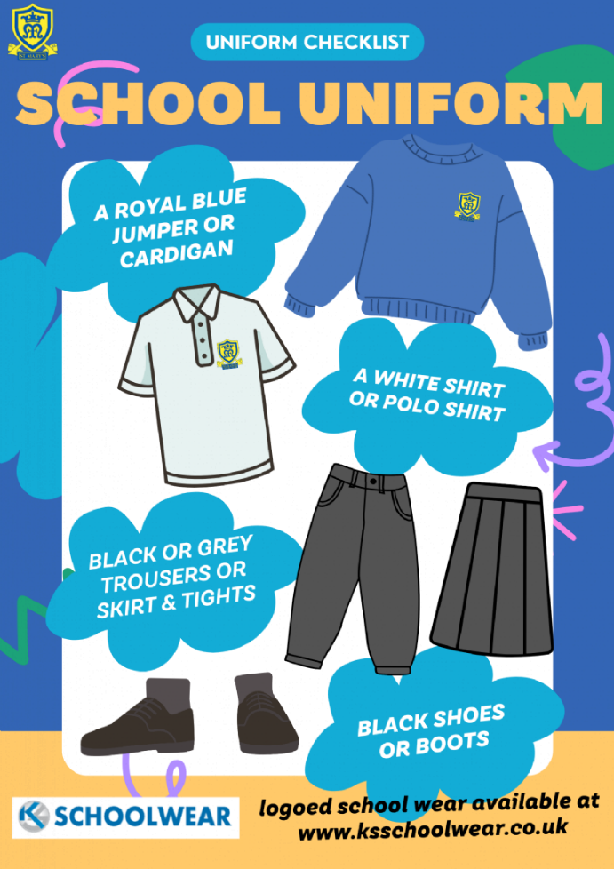
NB. Trousers and shorts worn in school for uniform must be appropriate uniform style material and ‘cut’, not sportswear or fashion styles.
The school strongly discourages the wearing of leather and expensive fashion coats/jackets since the school cannot take responsibility for loss or damage of items of clothing.

PE kit:
Trainers or plimsolls Black or blue PE shorts WhiteT-shirt
Tracksuit bottoms/Joggers may be worn for outside use in the winter months

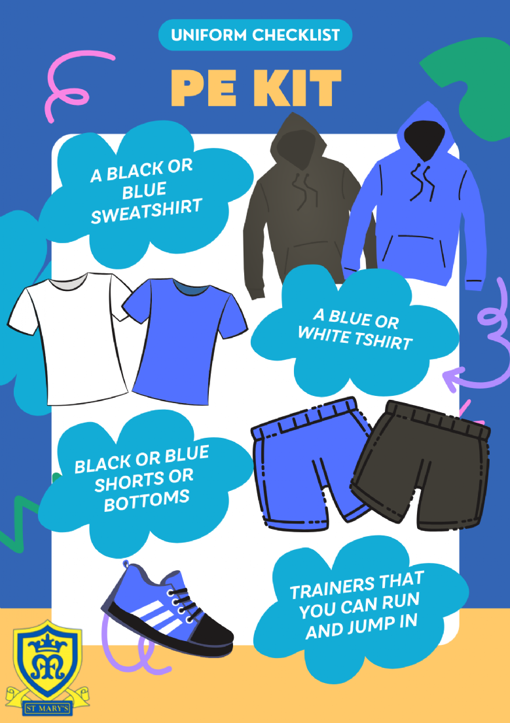

Please Note
All items of clothing, including shoes, should be clearly marked with the child’s name.

NB. The school has used the DfE non-statutory guidance on school uniform and agrees with the guidance given by the DfE which states:
“The school uniform plays a valuable role in contributing to the ethos of a school and setting an appropriate tone.”

Logo-ed uniform is available from www.ksschoolwear.co.uk but is not a requirement to buy this as long as the correct blue jumper / sweatshirt is worn.

We will sell second hand uniform approximately termly when we have enough donations / unclaimed unlabelled lost property to make a sale worthwhile. Should you want to access our second hand stocks in the interim, please see the office or inclusion team.

