
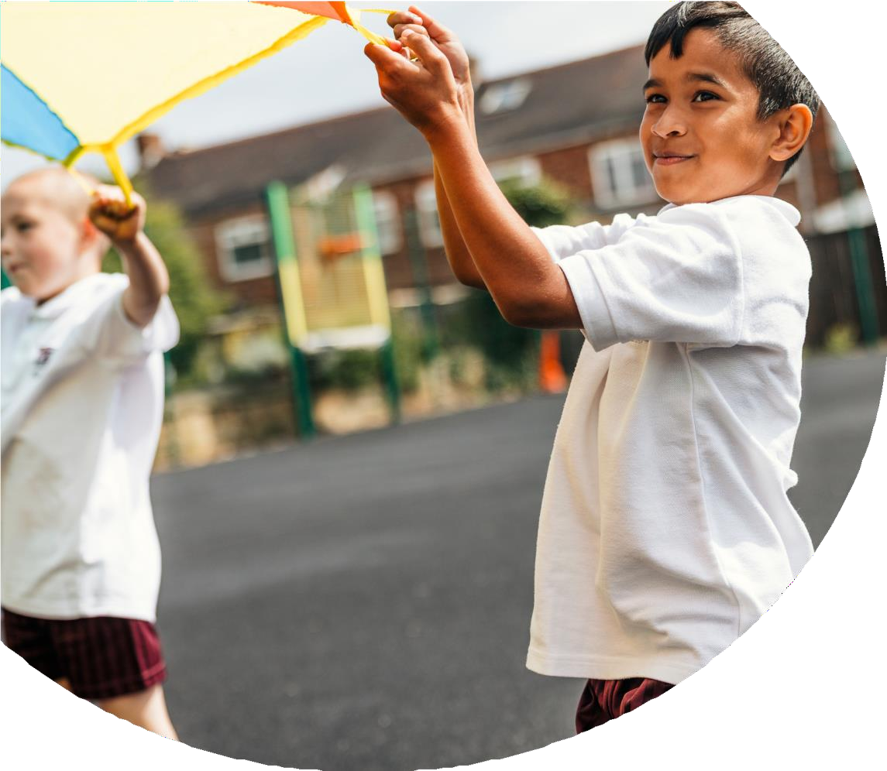
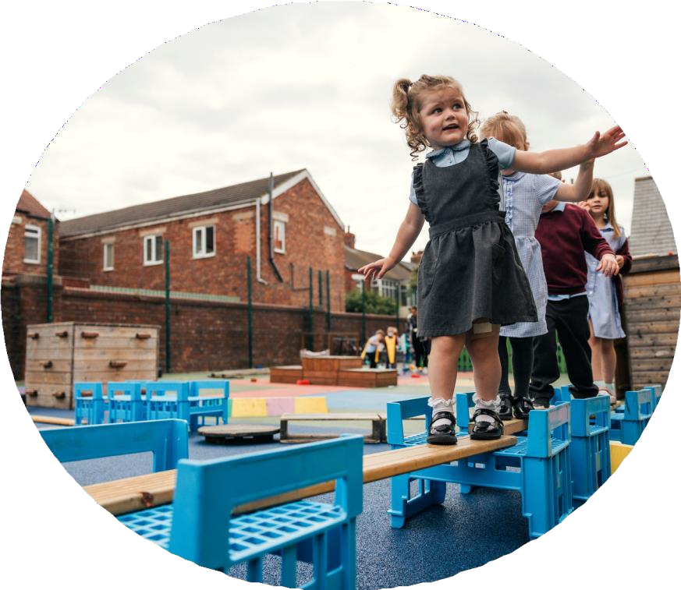

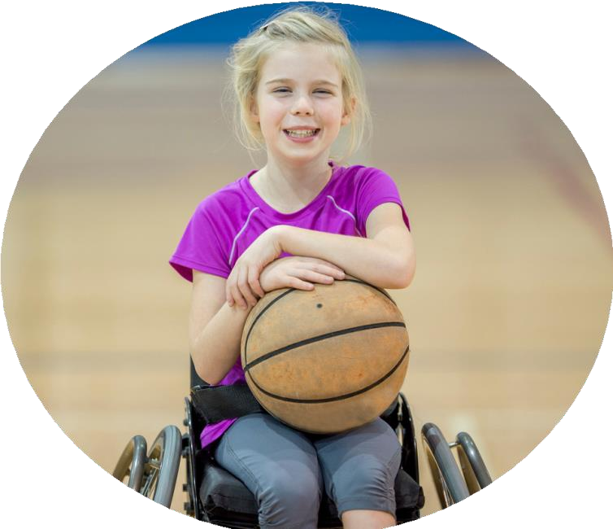


PE and sport premium
monitoring and tracking form 2025/2026

Commissioned by

Created by

Review of the last academic year (2024/2025)

Swimming and Water Safety | What went well? Supporting evidence? | What didn't go well? Supporting evidence?
1. Swim competently, confidently and proficiently over a distance of at least 25 metres | Pool used (Kettering), is a 25m pool so children were getting practise of the relevant length without needing to turn. 76% of year 6 children are competent swimmers and have fulfilled the 25m swimming assessment (23% of the year 6 children were competent swimmers at the start of the year) | Access to the pool and difficulty with consistent swimming teachers impacted grouping and progress. This was taken up with the local pool.
2. Use a range of strokes effectively (for example, front crawl, backstroke and breaststroke) | Children were taught these three strokes plus butterfly if they were in the top group. | Most children were proficient in front crawl and backstroke, breaststroke and butterfly was not taught as effectively.
3. Perform safe self-rescue in different water-based situations | This was established at the beginning of the sessions to try and keep all of the children safe during the lessons. | Safe water rescue in clothing was only taught to higher level groups.

Key areas as outlined in PE and  sport premium guidance | What went well? Supporting evidence? | What didn't go well? Supporting evidence?
1. Increasing confidence, knowledge and skills of all staff in teaching PE and sporting activities prioritising CPD and training where needed | Simple curriculum established across school (pehub) – all teachers share that the lessons are easy to follow and access.  Aspiration Week and sports days invited external providers into school.  Partnership with Northampton Saints and Days of Rugby supported staff in CPD. | Dedicated CPD to sports teaching could support delivery.
2. Increasing engagement of all pupils in regular physical activity and sporting activities | 66 free after school clubs have been run. 84% of the school cohort, 86% of SEN children & 81% of PP children have taken part in at least one after school club.  Established links with local business, so that children have a contact point to access clubs outside of school – KTFC, Illicit Skateboards, Northampton Saints Rugby, Dynamix Dance | Push to try to get 100% involvement – parents were contacted of children that did not attend.

3. Raising the profile of PE and sport across the school, to support whole school improvement | Aspiration Day and Day of Rugby were successful, supported by Northampton Saints and the Mintridge Foundation.  Free after school clubs
4. Offer a broader and more equal experience of a range of sports and physical activities to all pupils and ensure equal access to sport for boys and girls | 66 free after school clubs have been run. 84% of the school cohort, 86% of SEN children & 81% of PP children have taken part in at least one after school club.
5. Increasing participation in competitive sport | Intra school competition established as part of aspiration week. | Inter school competitions needs to be accessed.


Aims for the next academic year (2025/2026)

- Using your whole school priorities, school development plan and previous PE, school sport and physical activity data, set out your aims for the year ahead.
- Think about specific areas of need such as inactive girls, SEND and disadvantaged pupils
- Remember to also input your swimming data and reflections in the table located at the bottom of this page.
- Consider which of the 5 key areas improvements will be focussing on:
  - Increasing confidence, knowledge and skills of all staff in teaching PE and sporting activities prioritising CPD and training where needed.
  - Increasing engagement of all pupils in regular physical activity and sporting activities
  - Raising the profile of PE and sport across the school, to support whole school improvement
  - Offer a broader and more equal experience of a range of sports and physical activities to all pupils and ensure equal access to sport for boys and girls
  - Increasing participation in competitive sport

Swimming and Water Safety | Input data | Reflections
1. Swim competently, confidently and proficiently over a distance of at least 25 metres | 10% of children were proficient at the beginning of the academic year. 65% of year 6 were proficient swimmers at the end of the year. | Difficulty in group progress due to the amount of children with EHCP that found Swimming incredibly difficult due to cognitive understanding. Inconsistency in teachers made progression difficult.
2. Use a range of strokes effectively  (for example, front crawl, backstroke and breaststroke) | Children were taught these three strokes plus butterfly if they were in the top group. | Most children were proficient in front crawl and backstroke, breaststroke and butterfly was not taught as effectively.
3. Perform safe self-rescue in different water-based situations | This was established at the beginning of the sessions to try and keep all of the children safe during the lessons. | Safe water rescue in clothing was only taught to higher level groups.


Aims for the next academic year (2025/2026)

Aim | Why? | Key Area | Supporting Evidence
Promotion of external clubs | To promote external clubs and promote children taking part in activities outside of school | 3. Raising the profile of PE and sport across the school, to support whole school improvement
To provide different ranges of sport for after-school clubs. | So that children have the opportunity to try a club/sport/activity in a safe environment that they are familiar with and develop links to continue outside of school. | 4. Offer a broader and more equal experience of a range of sports and physical activities to all pupils and ensure equal access to sport for boys and girls
To compete in Inter School competitions | To increase the amount of children that take part in a competitive situtaion in Sport. | 5. Increasing participation in competitive sport
To develop relationships with Brightwayz | To connect with local schools for future sporting events. | 2. To engage all children in regular physical activity
To train children to become Sports Leaders. | To help develop active playgrounds and give children responsibility. | 3. Raising the profile of PE and sport across the school, to support whole school improvement
To have an ‘Aspiration Week’ | To give all children opportunities to to partake in a variety of alternative activities to those taught in the curriculum | 2. To engage all children in regular physical activity.

Plan, monitor and evaluate (2025/2026)

- Please aim to use this as a live working document through the year.

- Keep returning to this to evidence adaptations and progress made through the PESSPA opportunities you provide.
- There is no set number of objectives you must have.

- Make as many or as few as you see fit that will support your aims for the year ahead.

- Consider which of the 5 key areas improvements will be focussing on:
  - Increasing confidence, knowledge and skills of all staff in teaching PE and sporting activities prioritising CPD and training where needed.
  - Increasing engagement of all pupils in regular physical activity and sporting activities
  - Raising the profile of PE and sport across the school, to support whole school improvement
  - Offer a broader and more equal experience of a range of sports and physical activities to all pupils and ensure equal access to sport for boys and girls
  - Increasing participation in competitive sport

Plan, monitor and evaluate (2025/2026)

 | Intent – what is your  objective? | Implementation - How will you  achieve this? | Impact - What do you hope  to see? | Supporting evidence
Plan and monitor | Promotion of external clubs | Use of share and shine during a Friday worship/assembly.  Local external agencies attending school to build links by running clubs in school – children can then build relationships – this also, in turn, reinvests the fund back into the local community | Children attending outside clubs and sharing it with their peers – this will create a community of sporting interest. | Children bringing in their awards and achievements to share with peers.  Children attending the extra curricular clubs and continuing outside of the school.
 | What impact have you seen? | Are the improvements sustainable? How? | Supporting evidence | Approx. cost
Evaluate | A culture of sport has developed. Children have built fantastic relationships with key adults from local agencies – who now feel that they are part of the school family. | The culture and interest in sport is sustainable – relationships will continue into the next academic year. | Silver Award | Cost on external opportunities - £14,293.

Your Objective:

 | Intent – what is your  objective? | Implementation - How will  you achieve this? | Impact - What do you hope to  see? | Supporting evidence
Plan and monitor | To provide different ranges of sport for after-school clubs. | Use of the sports premium to set up and run free after school activities. | Attendance, interest and a culture of sport. | This is to build on a program of well-established after school activity.
 | What impact have you  seen? | Are the improvements  sustainable? How? | Supporting evidence | Approx. cost
Evaluate | Attendance of clubs has been strong and all clubs are oversubscribed. | The culture of clubs and the program is well established and now become the norm and expectation of parents and shareholders of the school. Sadly, due to the termination of the sports premium grant, free after school club provision has to stop at the end of the 25/26 academic year. We are going to continue our offer but at a small cost to parents. | A significant number of pupils including PP have accessed the provision  Silver Award | Cost on external opportunities - £14,293.

T

Your Objective:

 | Intent – what is your  objective? | Implementation - How will  you achieve this? | Impact - What do you hope to  see? | Supporting evidence
Plan and monitor | To compete in Inter School competitions | Attend competitions offered by external services. | Attendance of competition
 | What impact have you  seen? | Are the improvements  sustainable? How? | Supporting evidence | Approx. cost
Evaluate | School have attended competitions offered by external services. Popular competitions via pupil voice are both the school football league hosted by KTFC and the All girls rugby festival at Northampton Saints. | The team is established and the team will continue into the next academic year.  A girls Rugby team was also established at the request of the children. | Club information.  League attendance.  Relationships with external agencies.  Silver Award. | Cost on external opportunities - £14,293.

Your Objective:

 | Intent – what is your  objective? | Implementation - How will  you achieve this? | Impact - What do you hope to  see? | Supporting evidence
Plan and monitor | To develop a key relationship with Brightwayz | Liaising with Brightwayz and inviting them into school to work with children. | Workshops with children.  Cycle repair.  Teaching about walking to school.  Road safety awareness.
 | What impact have you  seen? | Are the improvements  sustainable? How? | Supporting evidence | Approx. cost
Evaluate | A huge impact in awareness by the children in getting to school.  A relationship has developed with the charity and this, in turn, has promoted the school in the local community. | Relationship is ongoing and we will work with Brightwayz on future events. | Silver Award.  Cycle fixing days at school.  Walk to school event – walking bus.  Mural on Stamford Road.  Workshops with KS1 and EYFS.  Bus shelter display – Stamford road.  School travel plan. | Free – Brightwayz are a charity.

Your Objective:

 | Intent – what is your  objective? | Implementation - How will  you achieve this? | Impact - What do you hope to  see? | Supporting evidence
Plan and monitor | To train children to become sports leaders | Application for the roll  Support and training to the successful candidates | Students serving as role models in setting up activities and looking after the equipment.  Supporting with playground issues.
 | What impact have you  seen? | Are the improvements  sustainable? How? | Supporting evidence | Approx. cost
Evaluate | Children have fulfilled the role – although some did not continue it throughout the year. | Change is sustainable – this was a good stepping stone for the OPAL project which is launching next academic year 26/27 – in which year 6 students are all expected to be play leads. | Silver Award

Your Objective:

 | Intent – what is your  objective? | Implementation - How will  you achieve this? | Impact - What do you hope to  see? | Supporting evidence
Plan and monitor | To hold an aspiration week. | A week set aside for sporting and community focused activities in order to promote a community focus. | Children to develop a enjoyment and interest in sport and community impact.
 | What impact have you  seen? | Are the improvements  sustainable? How? | Supporting evidence | Approx. cost
Evaluate | Aspiration week was successful. This included visits from external agencies and our sports day.  Children have a deeper understanding and community based focus. | Yes – aspiration week will run this academic year and continue into further years. | Silver Award

This page has been left blank for any notes or supporting information.

